Impact of passenger assaults on Uber
Group 5
Meet Patel – C0910378
Nishit Patel – C0908056
Rachit Bhatt – C0902810
Rajat Kumar – C0912858
Rojit Manandhar – C0913721
Artificial Intelligence and Machine Learning (Section 2), Lambton College in Toronto
COM 3013 2 [Online 8] Professional Communications
Prof. Rehab Alsayad
November 10, 2023

Introduction
Uber was designed to fulfill customer’s needs by making transportation easy, and in recent years, its ride-sharing services have revolutionized the industry. However, a significant concern that they have been trying to resolve is their passenger assault.
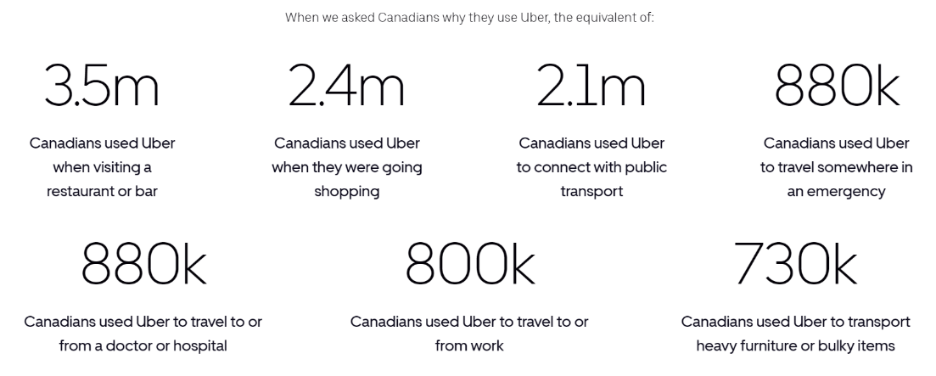
Figure 1. Shows the distribution of when does a customer book an Uber (PublicFirst, 2023)
Around 3.5 million cabs are booked when a customer is visiting a restaurant or bar, and because that usually takes place during the night, the rate of assaults has increased in cab rides (see Figure 1). Passenger assault is a severe concern that may scar people for life. Not only does it harm the passengers, but it also raises a high alert against the company with a lack of safety features. One of the Uber reports highlights the retrieval of 3824 reports including some shocking instances such as non-consensual kissing, molestation, and rape (Sara, 2022). Such incidents reduce the credibility of the company and impact in drop in users. Passenger assault in Uber is one of the major issues in Canada as it has been growing in the past years. It affects the safety of the users availing its services and the business economically.

Impact of passenger assaults on Uber
Passenger safety concerns
The persistence of assault cases of passengers in Uber ultimately creates a massive concern for the safety of the passengers. It leads to the passengers having to think twice before using the service. The increasing number of assault cases raises concerns for both the physical and mental well-being of the passengers (Chaudhry et al., 2018). In 2018, Uber disclosed the prevalence of a deeply rooted problem of sexual assault. Uber confirmed that 9,805 reports of sexual assault were made against them between the year 2017 and 2020 (O'Brien, 2022). In conclusion, the alarming number of assault cases in Uber raises great fear and concerns about the passenger’s safety while utilizing the service. It highlights the critical need for the company to take robust measures to prevent such incidents.
Legal Challenges on Uber
The occurrence of assault and violence on ride-sharing apps like Uber creates many legal challenges for the company. The most common challenge that Uber faces is related to the safety of passengers, predominantly female riders. In 2022, Slater Slater Schulman LLP, a firm that practices targeting safety issues on ride-sharing services, mentioned that approximately 550 clients claimed against Uber, and the rest 150 were being investigated (Joan & Anne, 2022). To summarize, the increasing number of claims and investigations presents a significant legal challenge primarily centered around passenger safety in Uber.
Reputation Damage
Passenger assaults are one of the critical factors that directly affect Uber’s reputation. As these assaults include physical harassment, rape, and non-consensual activities, it creates a substantial negative impact on the company. In the year 2019, people started a campaign “#DeleteUber” which was propagated by the news media. As a countermeasure, Uber spent a half-billion dollars by launching a marketing campaign to overcome the damage caused by the movement but failed to do so and had to fire a team of 400 employees (Faiz Siddiqui, 2019). Moreover, as recorded in a report, the cases rocketed by 45% over the period of two years, having 141 rape cases and 998 sexual assaults (Sara, 2022). Since CNN Business highlighted this report from Uber, it shows Uber accepts that these assaults directly impacted their reputation dramatically. Apart from that, a healthy amount of customers started opposing the use of Uber services as many news channels telecasted this news and contributed to the defamation of the company. Hence, the reputation damage creates a significant impact on the company.
Financial impact
Passenger assault cases and their coverage on news and social media create a negative image of Uber and severely impact their finances. This financial damage can be seen in the company’s stock value, market standing, decrease in investments, and many more monetary attributes. Moreover, legal settlements and compensation to victims can also impact their finances.
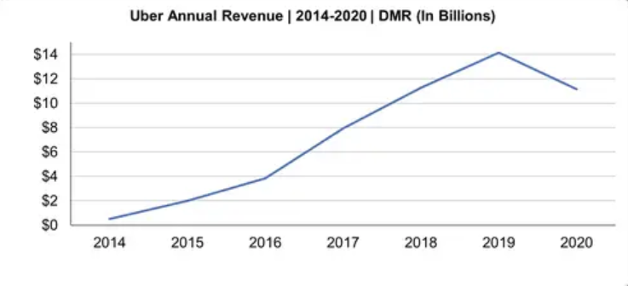
Figure 2. Uber Annual Revenue (expandedramblings, 2023)
In 2019, Uber reported a $1.4 billion loss in its stock market value after facing around three thousand assault cases, resulting in an annual revenue loss (see Figure 2). During that period, the closing price of Uber’s share was $27.88 after a drop of 2.7%, leading to a decrease in overall capitalization to $47.5 billion. This decline was caused by the negative publicity regarding the safety of passengers, increasing the concern of the company's management and the investors (Rex Crum, 2019). Uber had to undergo these times due to a lack of ride security. Therefore, passenger assault cases contribute to be a prime factor for the decline in Uber’s company’s stock values and the trust of stakeholders as well as people.

Conclusion
In conclusion, Passenger assaults in Uber have impacted in many ways by not only affecting the customers but also the company. Uber has many flaws that lead to passengers being assaulted across the country. While Uber aims to provide a good experience for transportation using their cab service, unfortunately, many passengers had to compromise on safety, which resulted in passenger assaults across Canada. With a rise in such incidents, there was a significant impact on their stock value. The impact of this was numerous allegations, legal charges, and reports filed against the company, resulting in the loss of financial and social reputation. While going through these atrocious times, there was a jolt on their esteemed value that ended up dropping not only their financial value but also their customer loyalty. Even though Uber started their business with an initiative to resolve the problem of transportation using the concept of ride-sharing, many passengers experienced an unfortunate fate while trying to avail the same. Hence, a large number of passengers stepped away from using their services across the nation to spare themselves from being a victim of such incidents that not only seems to be physical harm but also scars a person mentally for life.

References
Chaudhry, B., Yasar, A.-H., El-Amine, S. I., & Shakshuki, E. (2018, January). Passenger Safety in Ride-Sharing Services. Procedia Computer Science. https://www.researchgate.net/publication/324738504_Passenger_Safety_in_Ride-Sharing_Services
ExpandedRamblings 2023, Uber Statistics and User Count (2023) https://expandedramblings.com/index.php/uber-statistics/
Faiz S. (2019, August 29). Internal data shows Uber’s reputation hasn’t changed much since #DeleteUber. The Washington Post. https://www.washingtonpost.com/technology/2019/08/29/even-after-ubers-ipo-long-shadow-deleteuber-still-looms/
Joan V., Anne H. (2022, July 13). Uber Facing Lawsuit From Sexual Assault Survivors for Endangering Them on Rides and Failing to Put Adequate Protections in Place Cision. PR Newswire.
https://www.prnewswire.com/news-releases/uber-facing-lawsuit-from-sexual-assault-survivors-for-endangering-them-on-rides-and-failing-to-put-adequate-protections-in-place-301586028.html
O'Brien, S. A. (2022, July 14). Uber’s safety issues still loom large: Another five passengers sue company over alleged sexual assault incidents. CNN Business. https://www.cnn.com/2022/07/14/business/uber-sexual-assault-safety-lawsuit/index.html
PublicFirst 2023, The Impact of Uber in Canada https://ubercanada2023.publicfirst.co
Rex C. (2019, December 6). Uber loses $1.4 billion in value after reporting thousands of sexual assaults in its rides. The Mercury News. https://www.mercurynews.com/2019/12/06/uber-loses-1-5-billion-in-value-after-reporting-thousands-of-sexual-assaults-in-its-rides/#:~:text=PUBLISHED%3A%20December%206%2C%202019%20at,its%20U.S.%20rides%20in%202018
Sara Ashley O. (2022, June 30). Uber releases safety data: 998 sexual assault incidents including 141 rape reports in 2020. CNN Business. https://www.cnn.com/2022/06/30/tech/uber-safety-report/index.html

